**NAME OF THE QUESTION**

Spring Data JPA - Quick Example

**CODE**

**Ormlearnapplication.java:**

package com.cognizant.ormlearn;

import com.cognizant.ormlearn.model.Country;

import com.cognizant.ormlearn.service.CountryService;

import org.slf4j.Logger;

import org.slf4j.LoggerFactory;

import org.springframework.boot.SpringApplication;

import org.springframework.boot.autoconfigure.SpringBootApplication;

import org.springframework.context.ApplicationContext;

import java.util.List;

@SpringBootApplication

public class OrmLearnApplication {

private static final Logger LOGGER =

LoggerFactory.getLogger(OrmLearnApplication.class);

public static void main(String[] args) {

ApplicationContext context = SpringApplication.run(OrmLearnApplication.class,

args);

LOGGER.info("Inside main");

CountryService countryService = context.getBean(CountryService.class);

LOGGER.info("Start");

testGetAllCountries(countryService);

LOGGER.info("End");

}

public static void testGetAllCountries(CountryService countryService) {

List<Country> countries = countryService.getAllCountries();

for (Country country : countries) {

System.out.println("Country: Code = " + country.getCode() + ", Name = " +

country.getName());

}

}

}

**Country.java:**

package com.cognizant.ormlearn.model;

import jakarta.persistence.Column;

import jakarta.persistence.Entity;

import jakarta.persistence.Id;

import jakarta.persistence.Table;

@Entity

@Table(name = "country")

public class Country {

@Id

@Column(name = "code")

private String code;

@Column(name = "name")

private String name;

public String getCode() {

return code;

}

public void setCode(String code) {

this.code = code;

}

public String getName() {

return name;

}

public void setName(String name) {

this.name = name;

}

@Override

public String toString() {

return "Country [code=" + code + ", name=" + name + "]";

}

}

**CountryService.java:**

package com.cognizant.ormlearn.service;

import java.util.List;

import org.springframework.beans.factory.annotation.Autowired;

import org.springframework.stereotype.Service;

import org.springframework.transaction.annotation.Transactional;

import com.cognizant.ormlearn.model.Country;

import com.cognizant.ormlearn.repository.CountryRepository;

@Service

public class CountryService {

@Autowired

private CountryRepository countryRepository;

@Transactional

public List<Country> getAllCountries() {

return countryRepository.findAll();

}

}

**Countryrepository.java:**

package com.cognizant.ormlearn.repository;

import org.springframework.data.jpa.repository.JpaRepository;

import org.springframework.stereotype.Repository;

import com.cognizant.ormlearn.model.Country;

@Repository

public interface CountryRepository extends JpaRepository<Country, String> {

}

**OUTPUT**

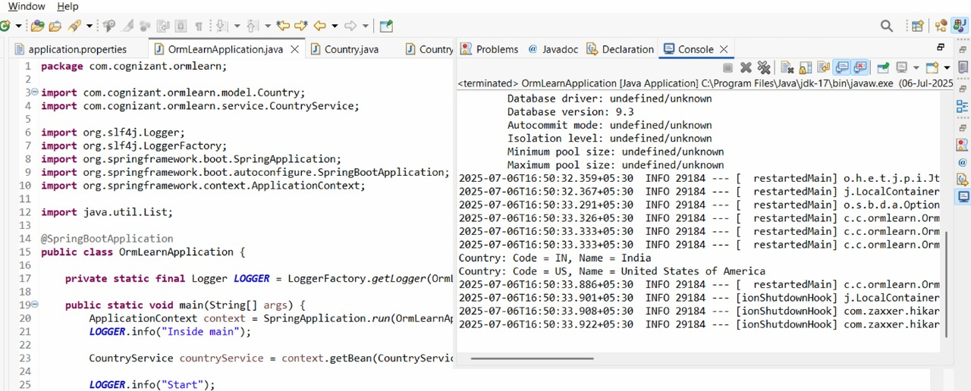

**NAME OF THE QUESTION**

Difference between JPA, Hibernate and Spring Data JPA

**CODE**

**employee.java:**

package com.cognizant.ormlearn.model;

import jakarta.persistence.*;

@Entity

@Table(name = "employee")

public class Employee {

@Id

@GeneratedValue(strategy = GenerationType.IDENTITY)

private int id;

private String name;

private double salary;

// Getters and Setters

public int getId() {

return id;

}

public void setId(int id) {

this.id = id;

}

public String getName() {

return name;

}

public void setName(String name) {

this.name = name;

}

public double getSalary() {

return salary;

}

public void setSalary(double salary) {

this.salary = salary;

}

}

**Employee repository:**

package com.cognizant.ormlearn.repository;

import org.springframework.data.jpa.repository.JpaRepository;

import com.cognizant.ormlearn.model.Employee;

public interface EmployeeRepository extends JpaRepository<Employee, Integer> {

}

**EmployeeService.java:**

package com.cognizant.ormlearn.service;

import com.cognizant.ormlearn.model.Employee;

import com.cognizant.ormlearn.repository.EmployeeRepository;

import org.springframework.beans.factory.annotation.Autowired;

import org.springframework.stereotype.Service;

import org.springframework.transaction.annotation.Transactional;

@Service

public class EmployeeService {

@Autowired

private EmployeeRepository employeeRepository;

@Transactional

public void addEmployee(Employee employee) {

employeeRepository.save(employee);

}

}

**OUTPUT**

